Binary data formats

What are Binary data formats
# Source: AI Source: Provided by: [Data Path: Persons Table -> ID Column: 1, Name_En Column: Motasem Essam] -> From: [Chatgpt (GPT‑5 Mini)] on [12/10/2025]
Binary data formats store data in machine-readable form (0s and 1s) instead of human-readable text. They are designed for efficiency, speed, and compact storage, but usually require special software to read or edit.

Common Binary Data Formats

1. Image Formats
# Source: AI Source: Provided by: [Data Path: Persons Table -> ID Column: 1, Name_En Column: Motasem Essam] -> From: [Chatgpt (GPT‑5 Mini)] on [12/10/2025]
- Store images in compressed binary form.
- Examples:
  - JPEG – compressed photos.
  - PNG – images with transparency.
  - GIF – simple animations.

2. Audio Formats
# Source: AI Source: Provided by: [Data Path: Persons Table -> ID Column: 1, Name_En Column: Motasem Essam] -> From: [Chatgpt (GPT‑5 Mini)] on [12/10/2025]
- Represent sound as binary data.
- Examples:
  - MP3 – compressed audio.
  - WAV – uncompressed, high-quality audio.

3. Video Formats
# Source: AI Source: Provided by: [Data Path: Persons Table -> ID Column: 1, Name_En Column: Motasem Essam] -> From: [Chatgpt (GPT‑5 Mini)] on [12/10/2025]
- Combine audio + images in binary encoding.
- Examples:
  - MP4
  - AVI
  - MKV

4. Executable Files
# Source: AI Source: Provided by: [Data Path: Persons Table -> ID Column: 1, Name_En Column: Motasem Essam] -> From: [Chatgpt (GPT‑5 Mini)] on [12/10/2025]
- Contain machine code that a computer can run directly.
- Examples:
  - .exe (Windows programs)
  - .bin files

5. Database & Big Data Formats
# Source: AI Source: Provided by: [Data Path: Persons Table -> ID Column: 1, Name_En Column: Motasem Essam] -> From: [Chatgpt (GPT‑5 Mini)] on [12/10/2025]
- Optimized for fast processing and storage.
- Examples:
  - Parquet – used in big data systems.
  - Avro – data serialization format.

Characteristics of Binary Formats
# Source: AI Source: Provided by: [Data Path: Persons Table -> ID Column: 1, Name_En Column: Motasem Essam] -> From: [Chatgpt (GPT‑5 Mini)] on [12/10/2025]
- Not human-readable (you can’t easily open them in a text editor).
- Compact size due to efficient encoding.
- Fast processing by computers.
- Often include compression and metadata.

Advantages
# Source: AI Source: Provided by: [Data Path: Persons Table -> ID Column: 1, Name_En Column: Motasem Essam] -> From: [Chatgpt (GPT‑5 Mini)] on [12/10/2025]
- ✅ Smaller file sizes
- ✅ Faster read/write operations
- ✅ Efficient for large datasets and media

Disadvantages
# Source: AI Source: Provided by: [Data Path: Persons Table -> ID Column: 1, Name_En Column: Motasem Essam] -> From: [Chatgpt (GPT‑5 Mini)] on [12/10/2025]
- ❌ Hard to read or edit manually
- ❌ Requires specific software to interpret
- ❌ Less transparent than text formats

Simple Comparison (Text vs Binary)
# Source: AI Source: Provided by: [Data Path: Persons Table -> ID Column: 1, Name_En Column: Motasem Essam] -> From: [Chatgpt (GPT‑5 Mini)] on [12/10/2025]
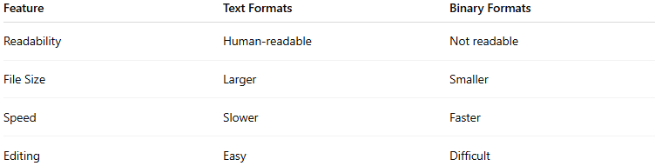
Feature | Text Formats | Binary Formats
Readability | Human-readable | Not readable
File Size | Larger | Smaller
Speed | Slower | Faster
Editing | Easy | Difficult

In short
# Source: AI Source: Provided by: [Data Path: Persons Table -> ID Column: 1, Name_En Column: Motasem Essam] -> From: [Chatgpt (GPT‑5 Mini)] on [12/10/2025]
In short, binary formats are best when performance and storage efficiency matter, while text-based formats are better when readability and flexibility are needed.

